**Employee Management System**

Employee Management (CRUD) System

**1. Project Description:**

A Spring MVC web application for Employee Information Management with the following CRUD operations:

* Get all the employees
* Add a new employee
* Update an employee
* Delete an employee

## 2. Tech Stack:

* Java 17
* Spring Boot
* HTML
* Bootstrap
* Thymeleaf
* Spring MVC
* Spring Data JPA
* Hibernate
* Maven
* MySql database

## 3. Installing:

i. Clone the git repo

<https://github.com/SaranyaBalasubramanian/GenTask/new/main/Project/EmployeeManagementSystem>  
  
ii. Open project folder

iii. Explore

## 4. How To Use:

i. Create Database -> EmployeeManageSystem

ii. Open project in preferred IDE (I used SpringToolsSuite4)

iii. Run project as Spring Boot App

iv. Hibernate will automatically create a table -> employee

v. Add sample data to table using MySQL Workbench Client

vi. Open web app at localhost: 8099/

vii. Add, Update and Delete records from web app

## 5. Demo:

### - All Employee UI

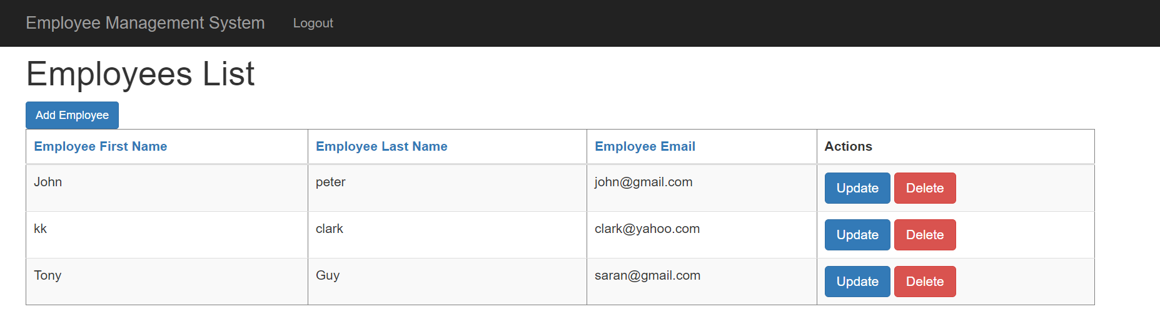

### - Add Employee UI

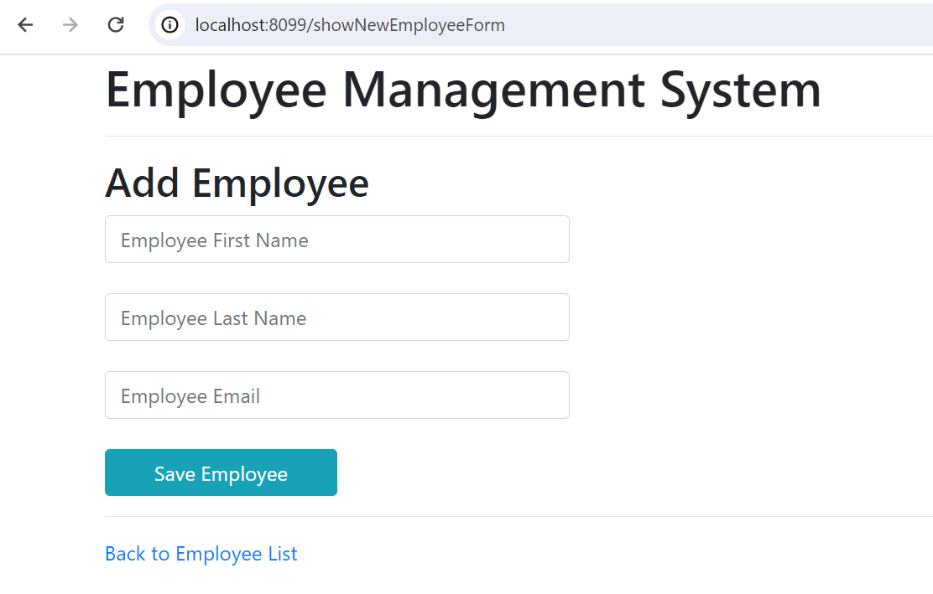

### - Update UI

